MASCIP end of year report 2024-2025
MASCIP
Balance 2024-25
EXPENDITURE | Total | Previous
 | Actual | year actual
Conference costs
Venue & catering | 15,755.70 | 15,618.65 |  | recce hire plus conference hire
Other conference costs | 1,467.50 | 1,459.14 |  | 3x £175 refunds and committee travel expenses
 | 17,223.20 | 17,077.79
Other business costs
Website | 5,585.00 | 1,900.00 |  | Website rebuild and maintenance
Conference prizes (+PKB) | 2,041.20 | 1,000.00 |  | 2x £175 prizes at conference, 2x contextual consulting courses (PKB), 1x £1000 PKB
Shared practice events | 0.00 | 0.00
Guidelines | 0.00 | 0.00
 | 7,626.20 | 2,900.00
Admin costs
Admin support | 3,186.33 | 2,008.63
Other expenses | 84.46 | 0.00 |  | Maria goodbye and TU gift
Other admin costs (stationery, postage etc) | 12.95 | 30.01 |  | Postage
Committee meeting expenses | 2,159.87 | 767.49
Bank charges | 19.25 | 30.00 |  | £15 foreign payment charge and £4.25 service charge (a monthly fee a 'community account')
 | 5,462.86 | 2,836.13
Total expenditure | 30,312.26 | 22,813.92
INCOME
Conference income
Conference delegate fees | 21,257.99 | 22,492.63
Conference exhibition/ sponsorship | 18,025.00 | 16,100.00
 | 39,282.99 | 38,592.63
Other income
Other sponsorship | 0.00 | 0.00
Bank interest | 0.00 | 0.00
Other income | 14.62 | 1,075.00 |  | £14.62 buffet only payment with CC fees deducted
 | 14.62 | 1,075.00
Total income | 39,297.61 | 39,667.63
BALANCE SHEET
 | 31/03/2025 | 01/04/2024
DEBTORS – Other debtors & prepayments
Outstanding income | 0.00 | 0.00
 | 0.00 | 0.00
CREDITORS – Other creditors & accrued expenses
Outstanding expenditure from 2023/24 | 0.00
Expenditure carried over to 2025/26 | 0.00 | 1,046.00
 | 0.00 | 1,046.00
 | 0.00 | -1,046.00
Cash at bank
Current account | 52964.76 | 43,979.41
Net assets | 52,964.76 | 42,933.41

Points for discussion:
- Online payments – Stripe – now says it can work with unincorporated associations but because we aren’t paying tax and have no tax ID I would have to use my personal details, my address, my phone number and my passport etc to prove our existence and activate the account. That doesn’t sit right with me, sorry.
- Insurance – we aren’t paying for any insurance. What if someone hurt themselves at the conference or followed a guideline and could prove that it had resulted in damage???
- List of companies that I have found that specialise in supporting unincorporated associations:
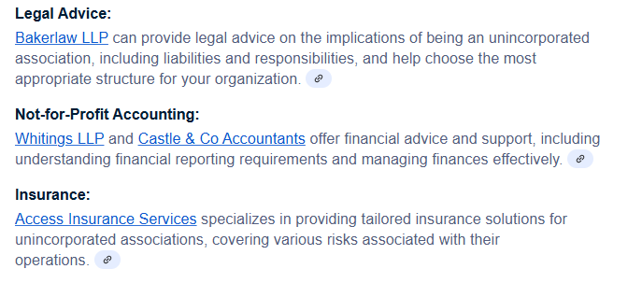
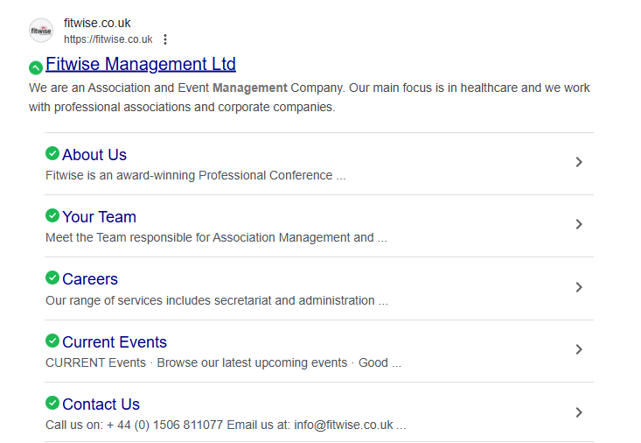
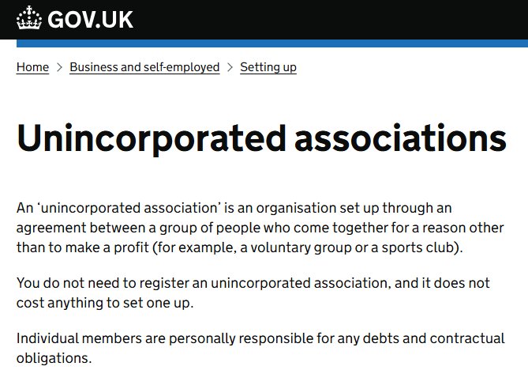

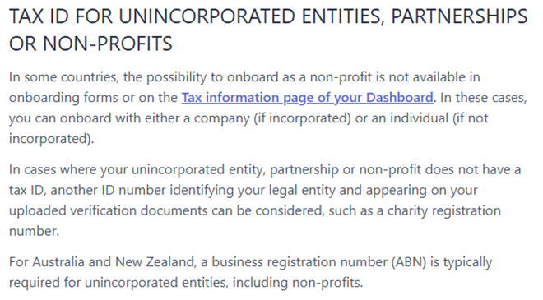

POINTS FROM LAST MEETING:
- Where I’ve got to with understanding Go Cardless and our need for a bank card:
From Dan: GoCardless is a Direct Debit payment gateway.
From the Go Cardless website: Collect instant, one-off payments. Or automated recurring payments. Without the chasing, stress or expensive fees.
i.e. it is managing incoming payments and nothing to do with us wanting to make one off small payments. Getting a bank card means we have a physical card that has to be in the right place at the right time and it circumnavigates the security process we currently use i.e. having to have all payments authorised by a second committee member. Personally I feel more comfortable if we don’t do that. Which means committee members pay for small costs themselves and are refunded for them by the treasurer. It feels more transparent. I can set up a direct debit for any regular payments we need to make, if there are any. Was there anything else that we needed the card for that this won’t cover and I’m missing?

- Stripe account – Emma, can we ask Dan if I can forget about this now? I assume we got far enough along the process to achieve what he needed to get the account set up? Are we going to find we meet a barrier at any point given that we couldn’t complete the process as we didn’t have the right tax information (as we are an unincorporated association).
- Legal status – unincorporated association / charity status and relative financial risk on us as the committee? My contact hasn’t come back to me. Benita was exploring an option. Eimear suggested speaking to her accountant – do they have specific experience working with our kind of organisation Eimear? Any other ideas? We’ve said we are willing to pay for proper financial advice but who do we go to? Any experience/ ideas welcome.

